The Recycled Man ….
…. who had two lives ….. November 2021
By Ken Aitken …
… When he was in hospital in February 1996

Summary Page:
In December 1995 I had a severe brain injury falling off a boogie-board in shallow water in the surf at Peregian Beach on the Sunshine Coast off Queensland, Australia. I was:

- In a coma for four weeks from early December 1995 to early January 1996.
- I felt like a three year old child in the first week after I woke up from the coma with no control over my actions
- In hospital for six months
- Had to learn everything all over again including walking, talking and eating solid food again
- Get my brain back together from a very scrambled state since December 1995
- I lost a lot of intuitive ability to feel what other people are saying ..... although that has come back now
- I am not the same man as before my accident. However I have learnt to work from what you have and not from what you have lost. It is new season in life.

At the moment these are my continuing problems:

- I cannot drive twenty six years (to 2021) out from my accident .... but I have learnt to drive on the Internet .... to go around the world in few minutes and see hundreds of people at the same time.
- My balance is still a bit out at the moment
- I cannot ride a bicycle now ….. Used to ride for kilometres when I had one when I was younger. I would now fall off a bicycle from a lack of balance
- I have to be careful in walking up narrow paths
- I have to come down backwards still on steep steps at home whilst holding onto the banister
- My mind has slowed right down …. It is hard to take initiative for one’s life and make clear decisions. The result of this for me, is that my wife Harriet now to manages all the finances on a day to day basis. Prior to my accident, we ran a small landscape design and construction business and I did most of that.

The Context Of My Brain-injury:

For twenty years, I ran a small Landscape Design and Construction Company undertaking very creative, individual designer gardens for wealthy residential clients around Brisbane. I was an artistic person, a lateral thinker ..... more artist than businessman. I thought of a landscape as a three-dimensional piece of space that people walked through. This space changed with time as it grew and changed with the time of day. Shadows vs. sun patterns, boulders, colour, plants, trees, earth-forms, solid structures and water. These were the ingredients I used. Unknowingly, I was a landscape sculptor. Rather an intangible product to sell and run a business with!! I built a structure for my life: my marriage, family and business from this base.

Harriet and I are into simplicity and recycling. We live in this amazing house built out of rejected materials for $32,000.00 in 1981 (40 years ago in 2021). We spent another $20,000.00 on it that the builder hadn't allowed for. See the house and garden on my personal experiences website at http://www.kenaitken.net/

See the following posts as an overview of the house and garden:
    - OUR HOUSE ….An Overview
    - OUR HOUSE …. The Actual Garden
    - OUR LAND OVERALL

That all changed overnight when I had a simple accident which resulted in severe consequences. I went through a real transformation of life.

___________________________________________________________
TRANSFORMATION OF LIFE DIRECTION: I went through a real transformation of life whereby I went from being:

1. Physical Gardener (Outer Sustainability) >>>>

2.Life Gardener (Inner Sustainability)

1. Outer Sustainability: ..... can certain practices be maintained ….. is what you doing now preparing the way ahead for a new garden which will growing successfully in twenty years time. I ran a small business in upmarket landscape design and construction for wealthy clients around Brisbane. It was called ‘New Earth Systems P/L’. It was a very difficult business in which to make a profit which depended on whether I had costed it properly. Each project was very non-standard and there was a seasonal nature of the work. Every project was a “one off”’. My former life was not sustainable ….. my creativity in my business couldn’t be standardised.

Since my accident, I have come to have a real passion for life. As part of that passion, I have come to value people. I have developed a passion to build inner community with many people around the world especially by e-mail. As I am on a permanently paid holiday through my lifelong Income Protection, I have time to spend with people in a way I never could do in my busy business.

2. Inner Sustainability: …. Can your life be maintained? ….. is what you doing now preparing the way ahead for new life? Inner sustainability flows from having a wholistic way of life where problems are dealt with by personal accountability. Inner determination then flows outwards.

Inner Life Gardens ..... Everyone of us has a private space in our lives that we carefully guard. I call it ‘The Garden of Life’. A garden is a personal space you can go out into and to enjoy the peace, the cool air, the shadows of trees, the sun shining with translucent light through tree leaves and palm fronds, the perfume of beautiful blossoms. No one else comes there except yourself and your family and close friends. They are invited out there with you after you have let them into your house. Strangers who come are intruders and will be dwelt with by the police.

It is the same with relationships. You have to enter someone’s inner life with their consent. You do this by understanding the persons inherent value and by listening intently to what they say. You are as it were gently knocking on the door of their inner house. If that person trusts you, they will then invite you into the inner garden of their life demonstrating that they accept the value you offer them. Then you can talk with them. They will open their door of their inner life at a later time if you knock. To keep that process going is a Sustainable Relationship. If I act suspiciously or try and crash the door with a sledge hammer, I will not be let in. That is what I call an Unsustainable Relationship.

Some Inner Life Gardens are very ordered whereas others are very weedy as people do not understand their value so anything goes. There are definite values and principles of life which really work. I say ‘Go through open doors, not closed doors …. Otherwise you will get a very sore forehead. …. Look not at closed doors of the past but look to find new doors of opportunity. That is why I have become an Inner Life Gardener (Inner Sustainability) to hundreds of people around the world to encourage them.

Inner Sustainability: In an ongoing personal sense …. Can your life be maintained to? ….. is what you doing now preparing the way ahead for new life? I have also discovered the significance of the Inner and Outer Life. Sustainability I have come to see, has to be a wholistic view on life of Inner, Middle and Outer Persons. Problems come because things do not change from the Outside to Inside but from the Inside to the Outside.

‘The Rose Water Story’ is my story from where I have come from and where I am going to.

The Rose Water Story

By Ken Aitken …

… When he was in hospital in February 1996

I was up working on a landscape construction site at Noosa Heads on the Sunshine Coast of Queensland in Australia for a friend of mine called John. This was early December 1995. We were staying down the coast further at Peregian Beach with one of John’s relatives. We had only been there two days and several of us went boogie-boarding in the surf after work. As a consequence I came off my board in the shallow surf, hitting the sand with my forehead and apparently John had to virtually carrying me out of the water with blood running from my nose.

He eventually got an ambulance to Nambour Hospital about half an hour away. This radical, life changing day was on the 4th of December 1995. I stayed in Nambour till 6th December when I was flown by the medical helicopter to the Princess Alexandra Hospital in Brisbane. Unbeknown to the doctors, I had multiple skull fractures. These could not be seen on the x-rays because of air running around in my brain. This resulted in the main cerebral artery being pinched off to the frontal part of my brain (This is the executive section of the brain).

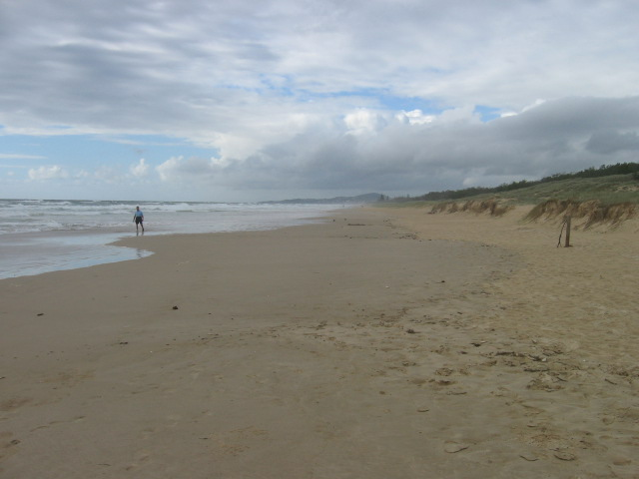
Peregian Beach where I had my accident on the 4th of December 1995 …... a quiet long beach of sand and small waves.

intern

On 8th Dec as a consequence of this clipping off of the blood vessel, I had a big bleed on the brain and I had to have an urgent brain operation. Because of the bleed, I completely lost my ability to walk, talk and eat solid food. I had severe ABI (Acquired Brain Injury). After coming out of Intensive Care Unit (ICU), I was placed in the Critical Care Section of M7, the ward for brain injured people.

While I was in Ward M7, the doctors believed I had damaged my thirst mechanism. I apparently did not know when to stop drinking. The doctors called this disease, Polydipsia. It was as if I had been in the Sahara Desert for two weeks with insufficient to drink. I had such an insatiable thirst that I dreamed of drinking all the water from the end of a running garden hose. I believed at the time the nurses were just being difficult when they forcibly limited my water intake to three litres of water a day. I have since found out from a nursing relative that in such a case as mine, it has been reported that if you drink too much water, your kidneys can fail from water overload.

The doctors had to ascertain whether my problem was physical or psychological so everything I drank was recorded on a chart at the foot of my bed. How to get a 230ml -hospital cup of water became the whole goal of my day. When the nurses came on ward rounds with torches at about four in the morning, I would be awake for the morning round, I would be awake for that welcome light. `Could I have some water, please?’

Polydipsia was such an acute problem that I felt on the edge of insanity. In M7, I desperately wanted the doctors to change their minds on the quantity of water I could have. In protest I began throwing anything from cutlery to boxes of tissues out the window. Fortunately, there was a metre wide shelf outside the window, which prevented things from hurtling down from the 7th floor to the pavement below.

One day two of my friends, Colin and Julianne had come to see me with their little baby. Even though I was in a coma, I heard them talking. When you are in coma you can hear people but cannot respond. Colin said to his wife ‘Ken will not be doing this in hurry’. Colin put the baby in my arms and I felt it lying there. The photograph which a nurse took is of that occasion.

___________________________
Ken in a comatose state December 1995
Colin my friend …………V
V
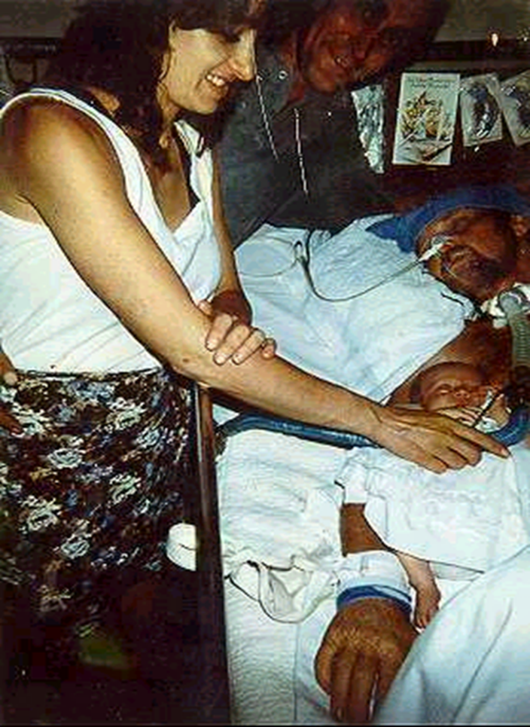l
__________________________

in February 1996, I was transferred to the Head Injuries Unit (HIU for short) in the same hospital. I still had this major thirst problem. I was so discouraged with this problem of how to get enough water to drink; I almost quit on rehabilitation. It was here that I had a very funny experience.

They still had me on water restrictions. I guess they were trying to get to the bottom of the problem. The nurses suddenly announced to me one night that I was to have a test. I had to fast from 9.00 o’clock that night to 7.00am in the morning. It was never explained to me the reasons for this test and as a result I saw it as the doctor’s test, not mine.

I was awake at 11.00 p.m. at night and absolutely dying of thirst. What could I do? I could get into my wheelchair or walk around by hanging onto the walls. I then saw the vase of roses in fresh water, which Harriet my wife, had brought in for St. Valentines Day, the previous day. This night would have been February 16th.

Grabbing onto the cupboard doors, I got out of bed. I took the roses and threw them into my wardrobe. I drank the vase of fresh water and said to myself `That is the best St. Valentines Day present Harriet could have given me!!’.

In the morning, at about 6.30 a.m. I was concerned for the wilted roses. I took the empty vase to the bathroom in my wheelchair. I was busily rinsing out the vase when Sister Clare who ran the ward came upon me and asked me ‘Did you drink the water from the vase?’ ‘Oh no’, I lied. ‘I’m just getting new water for my roses’.

A week later, my conscience was really nagging me about lying when she was showering me. I said to Sister Clare, ‘I have something to say to you. I DID drink the water from the vase. I am sorry I lied to you the other week’. Out of that confession came a lot of trust. I began to obtain water for myself and the problem of my thirst quickly went away.

If it was Polydipsia as I now believe it was, I don’t know how this event corresponded with my physical thirst. Somehow, the water restrictions were lifted, as the doctors never came back to check on my final outcome. I just know that period of my hospitalisation was extremely difficult. I only came to this understanding it was Polydipsia in late 1997. I believed the nursing staff were just being negligent with my water. I have perused the details of all this through my Medical File as I had permission from the Freedom of Information Officer at the PAH but I am none the wiser. (I can drink only two litres / day and not feel thirsty as I did in Hospital).

In HIU, therapists taught me to walk again and talk properly. My speech was very slurred and slow from what was called dysarthria, which comes from the muscles in your throat being affected. The therapists helped get my scrambled head back together again. In April 1996, I was just beginning to walk again instead of using a wheelchair. I also had to learn to write again. In March 1996, my level of comprehension was such that my speech pathologist had me doing simple definitions of words. My writing was so bad, she had me begin to type them on the computer so she could read it.

From there she had me begin to write a speech in preparation for my homecoming party when I came out of hospital in May. About 100 ++ people had come to see me in hospital over six months. From having to learn to write again I progressed: It began as ‘symbolic pictograms’ (almost childlike drawings), in M7, to very scratchy writing in HIU, to readable hand writing and to the use of my computer all over again when I got out of hospital.

Eventually I was able to leave hospital. I had been in hospital six long months. The day I was able to leave HIU was a day of intense elation. As Harriet, my wife, drove me down the driveway of HIU, I well remember the sense of accomplishment. I had made it! I had been in hospital for six long months from 4th December 1995 to 24th May 1996.

Before my accident, another significant incident occurred. Through my business connections, I had held an insurance Income Protection Policy for several years. One night in July 1995, (four months before my accident I didn’t know I was going to have), a man phoned me out of the Yellow Pages and said he wanted to talk to me about an Income and Protection Policy he was promoting.

I said, ‘I’ve already got one of those. I don’t need to talk to you’. We talked about rates and benefits for a while. They were far better than the policy I had. As a result, I went ahead with a different but small company at the time. If it had been my wife, she would have said ‘No’ as she would never talk to someone like that on the phone but fortunately it was me. This policy was for life and was CPI indexed. Four months later, I had my accident.

In many ways this accident and its consequences, has been the best thing that has happened to myself and the family and even though it has been a difficult experience. I have now been provided with an income much better than a Government Pension. I think there is irony and humour in this. I had worked hard all my life for very little, whereas now I don’t have to work at all. I am now on a permanent holiday for life and yet I still get paid for it. It is quite adequate for our needs and Harriet can work as well. We own our house well, so we do not have mortgage payments to make every month.

As I have a ‘Christian Spirituality’, God as my Heavenly Father supplied freely and worked things out for good for us long before I could even think it out. As I am on a permanently paid holiday through my life-long Income Protection, I have time to spend with people in a way I never could do in my busy business.

Through this ‘Christian Spirituality’, there has been an ongoing connection with a Personal Higher Power (God), and has brought healing, restoration and transformation of life purpose. It is about a dynamic and ongoing relationship with God that has very practical consequences.

_____________________________
Ken Home, Seven Months after the Accident …. June 1996
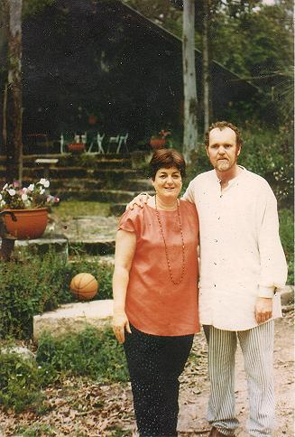
Ken with his wife Harriet at their house at Chambers Flat
In 1981, we built a unique natural house out of recycled timber for a fraction of the price of a new house. People often come out to see this house. I had run an environmental landscape design and construction business for twenty years so I had the skills to put things together like this. This is on our five acres of light open eucalypt bush at Chambers Flat, Brisbane. The house is largely of glass set into a post and lintel construction of 100 ++ year old broad axed timbers and sandstone walls. The total concept of indoor-outdoor flow, has a nice ambiance to it and the design is unique and is great place to live and have a sense of belonging. See the house and garden on my new personal experiences website: www.kenaitken.net See the actual links to our house and garden as given a few pages on.

An International Perspective ….. Ken and Harriet’s Travel post from 2003 to 2017.

Harriet (my wife) and I have been travelling overseas every two years to see the world. In between we have been seeing parts of Australia which is a very large country. We are also a
member of Wyndham Vacation Resorts Asia Pacific (a holiday share organisation) where we have available free accommodation in 3 star apartments around Australia. These are largely free of cost.
We both love history and it is very profound to us. People express their ideas on life in the way they build and arrange their living spaces. It is a bit hard to go back to 79 A.D. when Pompeii as a thriving Roman city and was buried with so little warning by 5-6 metre of Volcanic ash from Mt. Vesuvius. Pompeii was literally frozen in time.
Watch the Destruction of Pompeii by Mount Vesuvius, Re-Created with Computer Animation (79 AD)

You can easily spend a whole day walking the original stone cobbled streets looking at all the houses, temples, public baths and shop fronts.
People express their ideas on life in the way they build and arrange their living spaces. They maybe largely ignorant of you and the way you live and where you even live. Here are some years and countries we have been to:
- Trip 1: 2003: England, Trip 2: 2005: Italy, Trip 3: 2007: France, Trip 4: 2008: Canada,
- Trip 5: 2009: England again, Trip 6: 2010: The South Island of New Zealand,
- Trip 7: 2011: China trip, Trip 8: 2012: a two week holiday up in the Kimberleys in Western Australia,
- Trip 9: 2013: Scenic Tours: Amsterdam for two days then a river cruise for 14 days from Amsterdam to Budapest on the Rhine river with Scenic Tours. See this website. We then personally caught a train to Prague (six hours), stayed for two days and then we flew home via Singapore after 3.5 weeks of being away. We came back on the 29th of July
- Trip 10: 2014: South Africa and Madagascar and now with Voyages to Antiquity … Cruises to Ancient Civilisations in May 2015
- Trip 11: 2016: THE USA HOLIDAY for six weeks from 23rd September – 8th November
- Trip 12: 2017: Japan for 16 days from the 4 – 19th August 2017Trip 13:
- Trip 13: Voyages to Antiquity: … Cruises to Ancient Civilisations in September 2017. We sailed from Lisbon (in Portugal) to Rome over 17 days across the top of the Mediterranean Sea … we saw:
  - SPAIN: Cadiz, Malanga, Valencia, Barcelona
  - FRANCE: Carcassonne, Marseilles, French Rivera
  - ITALY: Florence (by bus), Rome …. Colosseum etc.
When the trip finished in Rome, Harriet and I took another week going up by train to Lake Como then down to Milan for two days. Then we flew home to Brisbane via a night in Dubai. It was six hours from Milan to Dubai and thirteen hours from Dubai to Brisbane ….. a long way to travel.

On the way up to Lake Como, we stopped off at Assisi for two days then Vernon for two days then Bellagio, Lake Como for two days. Then we went down to Milan for two days on our way home. I came back home with about 5,250 ++ photos of the whole trip.

_____________________________
See our Travel Post at this website:

4. OUR TRAVELS AROUND THE WORLD 2003 – 2017

See the different countries we have been to and the many posts on each county.

Photographs from March 2003 at the ancient Roman town of Bath in England ….. Harriet, my wife and I went on a four week holiday to England. We had an amazing time for a whole day in the ancient city of Bath.

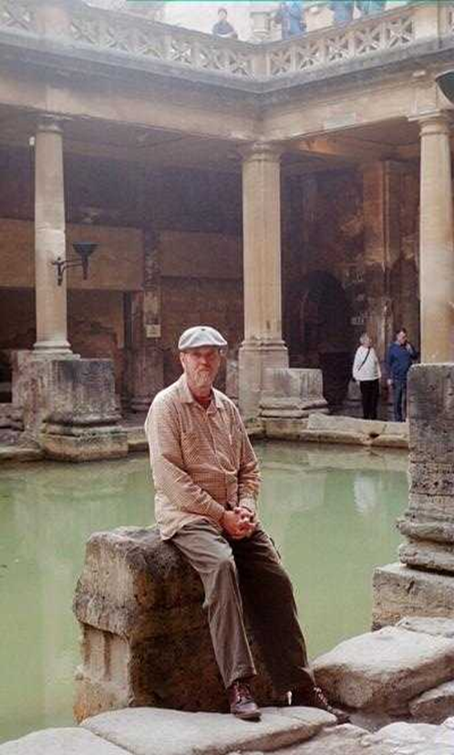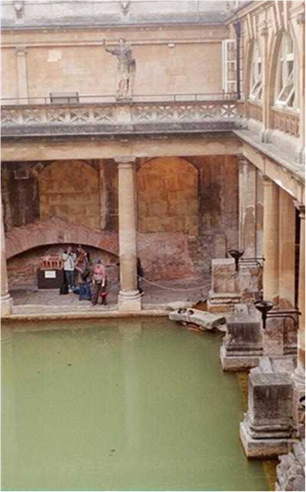
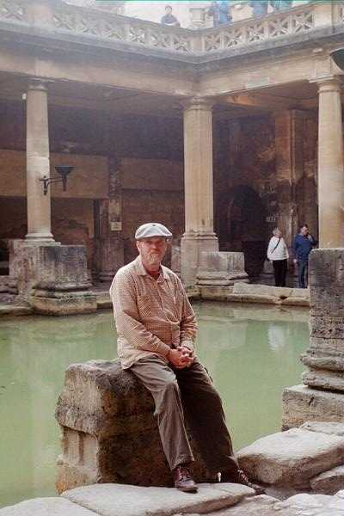
The baths are from the first and second Century from Imperial Rome. Founded by the Romans as a thermal spa, Bath became an important centre of the wool industry in the Middle Ages. In the 18th century, under George III, it developed into an elegant town with neoclassical Palladian buildings, which blend harmoniously with the Roman baths.

The Recycled Man

It is now twenty six years from this period of time in my life = 2021. In this time I have called myself the ‘Recycled Man’. I still cannot drive but my wife can drive me around or I use public transport. One major consequence of this new life is that I now have a passion to build inner community with many people.

Harriet and I as a married couple are experiencing a real renewed joy of being together. When we were married 46 years ago in December 1975, we talked about how we were like the eagle and the sparrow. I was the eagle who flew high in the heavens and saw the big picture of life and Harriet was the sparrow who saw more the detail of life. Then we would say how the eagle had to come down to the ground or it would starve and the sparrow had to frequently fly up or it would grow so fat, there would be no flying.

Some of the things Harriet and I are experiencing together are these sorts of things:

- Primarily we have a Christian Spirituality which we share a richness together in.

- We are really experiencing the beauty of an amazing home, garden and acreage at Chambers Flat, Queensland, Australia. We live in this amazing house built out of rejected materials. See our house and garden if you haven’t looked at these before:

- OUR HOUSE ….An Overview

- OUR HOUSE ….The Actual Garden See the photos of the house and garden and the history of how we obtained rejected materials like the Supreme Courthouse stone (where the Law Courts are now in Brisbane) …. two loads for nothing in 1980. They dumped 100's of cubic metres as fill and built a school over the top. The stone was cut out of the Kangaroo Points Cliffs in 1877.

- OUR LAND OVERALL

_____________________________
Our two children have left home and doing some new things.

- Our daughter Claire Aitken was married to Kieron Jarvis on the 24th June 2017. This was a very significant event. See the Wedding post for photos and what I have said as to why it a very significant event.

- Our 39 year old son Anthony has come to live with us again after ten years of being away. He has acted as a tour manager for firms who engage him . These firms signed him up because they are bringing in international music bands into Australia. He had to work out all the tour details for each band. He is very detailed, practical and organising .... he loved it!! He takes after his mother Harriet.

We all went to Melbourne in July 2015 to attend the funeral of Harriet’s mother Heather Kent. Heather was 97 years old and the funeral was packed out. There were even people there who Heather wouldn’t have seen for 20 years. Heather was a real family woman. Anthony suddenly experienced the value of family. Anthony was also one of the pall bearers along with other grandsons. That is why Anthony has come to live with us again after ten years of being away. He has become very family orientated and wants to look after us in our later years. He has come to love and appreciate our house built from recycled materials. He has come to help build ‘The Aitken Legacy’ longterm.

He has become very focused on tree houses and has selected a large tree down the back of our bush block land. He has already built the initial platform 4.5 metres off the ground. The dome is still to built. He has formed a Treehouse Club on Facebook. In September 2016 he had 347 members and now in August 2021, he has 37,400 members. See the photos of completed treehouses from around the world.

In November 2015, he flew over to Oregon, USA to meet Michael Garnier who has a whole business in building tree houses. He came back with a whole suitcase of special hinged bolts that you can use on a tree without hacking into the tree. He getting really serious. See the post:
ANTHONY, OUR SON, BUILDING HIS TREE HOUSE ON OUR LAND
Anthony says that I have sown many seeds into his life that have sprouted into what is doing now. He has become very focused on tree houses and has a big tree down the back of our bush block land where he has built his own treehouse. He has formed the following:
- Treehouse Club on Facebook. In September 2016 he had 347 members and now in August 2021, he has 37,400 members. See the photos of completed treehouses from around the world.
- http://www.treehouseclub.net/ …… High In The Trees since 2015. There are dozens of contributions from people around the world on building treehouses.
In November 2015, he flew over to Oregon, USA to meet Michael Garnier who has a whole business in building tree houses. He came back with a whole suitcase of special hinged bolts that he can use on a tree without hacking into the tree. He was getting very serious.

Anthony has also built a big Timber Yard on our land after he finished building the mid-deck of his treehouse as of April 2018. See the post:
OUR LAND OVERALL
See the many photos of the Timber Yard at the end of the post.
__________________________________________________
As I said before, for twenty years, I had run my own business in Landscape Design and Construction, doing very creative individual designer gardens for wealthy residential clients. I was more an artist than businessman. I thought of a landscape as would a sculptor in a solid medium, but I saw it as a three-dimensional piece of space which people walked through. This space changed with time as it grew and changed with the time of day: shadows vs. sun patterns, boulders, colour, plants, trees, earth-forms, solid structures and water.

These were the ingredients in a subtle flow of landscape design and construction. Rather an intangible product to sell and run a business with!! Two specific posts of my past gardens are these:

- Greenmount Beach Resort: http://www.kenaitken.net/my-past-work/greenmount-beach-resort-1980-2008/ 1980-2008/ … 28 years on from when I did the garden in 1980

- Sheehan's Garden: http://www.kenaitken.net/my-past-work/sheehan-garden-october-2007/ in October 2007 .... House and Garden in West End, Brisbane … 23 years on from when I did the garden in 1984

I wanted to be successful in making money but the creative side and the financial success of the business were in constant tension. With the landscape business I was in, there always had a severe downturn in winter.

The year of the accident, I had very little work and money was very short as a result. It was the worst year for business I have been through in twenty odd years. I felt under incredible stress and my wife Harriet and two teenage children were really feeling the pressure as well.

I was under such extreme pressure from the lack of work and at a point of desperation. I as ready to give it all away. I didn’t know which way to turn as I had invested years of study and resources into my chosen career and now it seemed fruitless. I had finished a B.Sc. at University of Queensland in the early 1970’s and had completed most of a Graduate Diploma in Landscape Architecture at QUT in the late 1980’s. I found it is impossible to have business and exam deadlines running together and on one very important project, I had let an important exam assignment pass by.

I was more an ideas, admin and marketing sort of person, good at the design side but not so good at the practical implementation side of the business. Because of the fluid nature of a garden, it was very difficult to be involved in just design, without having to get fully involved in the production side.

Give me any site, no matter how difficult and I would come up with a range of possibilities which were practical. I had a very sharp awareness of what I wanted to achieve but not always the best to make a profit even though I always planned to make one! However, I loved doing what I did.

I was more an artist than businessman which caused STRESS. As I have said before, In 1981, we built a unique natural house out of recycled timber which people often come out to see. It was for a fraction of the price of a new house. As I had run an environmental landscape design and construction business for twenty years, I had the skills to put things together like this. This is on our five acres of light open eucalypt bush at Chambers Flat, Brisbane. The house is largely of glass set into a post and lintel construction of 100 ++ year old broadaxed timbers and sandstone walls. The total concept of indoor-outdoor flow, has a nice ambiance to it and is great place to live and have a sense of belonging.
See this post on my Personal Experiences website:
1. THE HOUSE …. A Handmade House vs. A Machine – Built House

_____________________________
TRANSFORMATION OF LIFE DIRECTION:

With my brain injury, I went from being:
1. Physical Gardener (Outer Sustainability).

>>>>>>>>>>
1. Outer Sustainability: In a gardening and agriculture sense ….. can certain practices be maintained….. is what you doing now preparing the way ahead for new life? It was a very difficult business in which to make money, mainly due to the very non-standard and the seasonal nature of the work. My former life was not sustainable ….. my creativity in my business couldn’t be standardised vs. a successful business needs to be like a biscuit cutter …. Making a few $$ off large numbers of component

2. Life Gardener (Inner
Sustainability)

2. Inner Sustainability: In an ongoing personal sense …. Can your life be maintained to? ….. is what you doing now preparing the way ahead for new life? I have also discovered the significance of the Inner and Outer Life. Sustainability I have come to see, has to be a wholistic view on life of Inner, Middle and Outer Persons. Problems come because things do not change from the Outside to Inside but from the Inside to the Outside.

_____________________________

Inner and Outer Life:
Everyone of us has a private space in our lives that we carefully guard. I call it ‘The Garden of Life’ A garden is a personal space you can go out into and to enjoy the peace, the cool air, the shadows of trees, the sun shining with translucent light through tree leaves and palm fronds, the perfume of beautiful blossoms.

No one else comes there except yourself and your family. Even friends do not just drop in. They are invited out there with you after you have let them into your house. Strangers who come are intruders and will be dwelt with by the police.

It is the same with relationships. You have enter someone’s inner life with their consent. You do this by valuing the person with great value and listening intently to what they say, as though it absolutely important. By listening intently (consciously in a rational way and unconsciously with your intuition), you are as it were gently knocking on the door of their inner house. If that person trusts you, they will then invite you into the garden of their life. Then you can talk gently back and forth and then you have established a relationship with them. They will open their door of their inner life at a later time if you knock. To keep that process going is a Sustainable Relationship. If I act suspiciously or try and crash the door with a sledge hammer, I will not be let in. That is what I call an Unsustainable Relationship.

Some Inner Life Gardens are very ordered whereas others are very weedy. Some people do not know where they are. There are definite values and principles of life which really work in everyday life. I say ‘Go through open doors, not closed doors …. Otherwise you will get a very sore forehead. …. Look not at closed doors of the past but expect to find new doors of opportunity in life in the future which will open up for you’. That is why I have become an Inner Life Gardener (Inner Sustainability) to hundreds of people around the world.

___________________________
Spirituality: Spirituality is the unseen dimension of life. This unseen dimension of life has a direct effect on our lives here and now, if we let it.

It is a relationship with the universe and the personal higher power (God). We have an outer person (our physical body), middle person of mind, will and emotions, (our soul), inner person (our spirit). If our confidence and sense of identity is only in the first two areas, these can be taken from us in a moment but an ongoing personal relationship with a personal higher power (God) is a permanent restoring aspect of life (i.e. this is our definition of a sustainable life).

More specifically then, our spirituality is implicit, i.e. is inward, self evident and undefined. It refers to how the individual lives meaningfully with the ultimate questions of life, his or her response to the deepest truths as he or she comprehends these. There is a very real invisible spiritual world. It answers such queries as:

• Who we are as people?
• What is the meaning of life?
• What values should I live by?

It is much deeper than being a rational experience of the mind, or just a belief in something, but is a dynamic quality of life with interacts with everything you do. It has very practical effects on such things as your self image, your work, family, social network and the whole of life.

We all have a spirituality of some kind to explain the world. A spirituality is very powerful in the way it integrates our lives and the lives of many others. In the end, spirituality leads to significance in life. There is initially a Horizontal Spirituality which links us with each other, of me to you and you to me. Then it links us further to the physical world and it gives us directions on our relationship with the Earth and all other living creatures. Then there is a Vertical Spirituality which gives our relationship with a Personal Higher Power who is the infinite - personal God. Another way of describing this spirituality is in this way:

The Internal Spirituality: …. The Interconnectedness of all life: The Spirituality of the Interconnectedness of all of life.
This Internal Spirituality links things between the living and non living …. This leads to a horizontal spirituality with the purpose to aid others to a better quality of life and belief system.

The External Spirituality: Leads to the infinite-personal God …. Transcendent .…... outside the Created Cosmos …. This is a vertical spirituality …. Any healing and restoration has to come here then spread out horizontally to the spirituality detailed below.

For me, I in having a Christian Spirituality, means that there are two parts to the world: An invisible Spiritual Realm and a very visible Created realm. The first part 'The Invisible Spiritual' leads to a focus on the Presence of God through the Holy Spirit with what I call a Christian Spirituality. It is a 'Spirituality from Jesus Christ'. This is quite different to a Christian religious approach. See the differences below.

When I speak about Christianity, I mean a Christianity which is focused on the resurrected Jesus Christ. It is also focused on the Holy Spirit who He gave to be His personal representative to each person here on earth. It is a Spirit-filled Christianity and not a ritualised, hierarchal Christianity that has Corporation view of itself. Harriet (my wife) and I personally share in the life of this 'Spirituality from Jesus Christ'. It is this life which has sustained us and our family of two children since my severe brain injury twenty six years ago. It enabled us to go on four week holidays around the world.

_________________________
Spirituality is quite different to Religion. Spirituality is implicit (inwardly self evident and undefined). It refers to how an individual lives meaningfully with the ultimate questions of life, his or her response to the deepest truths of the universe as he or she apprehends these. It answers such queries as:

• Who are we as a people?
• What is the meaning of life?
• What values should I live by?

Religion is explicit (outwardly evident and defined) and is marked by four things: a cult, creed, code (ethics) and community (which is more inward looking). My concern and passion now is to make a major difference in the world. This is to connect and share with other survivors as well everyone around the world and share some of my hope and love for life.

____________________________
The Explicates of a Christian Spirituality:

A Christian Spirituality is built on an understanding that you and all things around you are here by a Special Creator who is The Infinite Personal God.

A Christian Spirituality is based on what God has revealed through His son Jesus Christ and His Word the Bible. It is based on an everlasting covenant that God initiated when He created man in the beginning. This covenant exemplifies God's unconditional love for us, His grace and His mercy towards us through the death and resurrection of His son Jesus Christ. He has made a way for us to be accepted for who we are and not what we have done.

_____________________________
The essence of a Spirituality from Jesus Christ is God coming to us in the human form of Jesus Christ. It isn't about us reaching to be spiritual or to find God. God comes to us instead and everything flows from that. Jesus Christ was not another spiritual prophet to lead us to God .... where all Spiritualities are considered equal in our Post Modern culture. God comes to us in the human form of Jesus Christ which opens up many new life possibilities where God through his indwelling Holy Spirit wants to be in a long-term relationship with us for all eternity. God wants us to be with Him forever ..... He is passionate about us .... He comes to us. (This is a non gender description and includes male and female personhood).

It is a question of identity deep on the inside. Who are you deep on the inside? The importance of identity determines your destiny. A new identity in what God thinks of you leads to a new passion in life and what you have called you to do. God thinks you are AWESOME!! He wants you to be with Him for eternity. To enable that, He sent Jesus Christ into the world 2000 years ago to bring this about.

This new identity was not based on your personal achievements in life or lack of them. It was not based on what other people thought about you or didn't think about you. This what could be called a 'Horizontal Identity'.

The new identity Jesus Christ spoke about was based on a 'Vertical Identity' ..... of who God said they were. This new identity that Jesus called people to was not in good words which they could believe or not believe in. It was demonstrated in power ..... things happened .... people were healed of diseases, the crippled walked, the blind saw, the deaf heard, the dead were raised and there powerful encounters with demonically possessed people. With a new identity, came a new sense of belonging which transcended their given definitions who other people said they were.

A Spirituality from Jesus Christ results from a Biblical Spirituality which begins with the Bible. There is a truth concerning God and the whole of life. It was a ‘True Truth’ communicated by God who sees the whole Cosmos as the large picture plus you and I as part of the detailed small picture. Seeing God is the Creator of all things, God knows the final truth. This truth was communicated by prophets and seers over many years and finally in person in Jesus of Nazareth who was God Himself in human form. These truths were collated in the Bible which consists of sixty six books written by people who didn’t often know each other over 1500 years ++ yet whose writing manifests an amazing unity. In this unity there is even a mathematical sequence which flows from the beginning to the end.

The books of the Bible are divided into two sections: The Old Testament and the New Testament. The Old Testament is the story the nation of Israel which predicts the coming of the Messiah. The Messiah came in the person of Jesus of the New Testament as the New Israel.

There are some striking parallels like an intricate Biblical clockwork within the bigger Biblical clockwork. This gives us even great confidence in the Word of God as the Word for the Old and New Testament.
__________________________
The Covenant …. a Biblical Overview:

In the Old Covenant of the Old Testament is the New Concealed and in the New Covenant in the New Testament is the Old Revealed … Jeremiah 31: 31 -34 "The time is coming," declares the LORD, "when I will make a new covenant with the house of Israel and with the house of Judah.

32 It will not be like the covenant I made with their forefathers when I took them by the hand to lead them out of Egypt, because they broke my covenant, though I was a husband to them, "declares the LORD.

33 "This is the covenant I will make with the house of Israel after that time," declares the LORD. "I will put my law in their minds and write it on their hearts. I will be their God, and they will be my people.

34 No longer will a man teach his neighbour, or a man his brother, saying, 'Know the LORD,' because they will all know me, from the least of them to the greatest," declares the LORD.
___________________________
A 'Vertical Identity' … A Further Understanding

There is a very famous passage in John 3:16,17 "For God so loved the world that He gave His only begotten Son, that whosoever believeth in Him should not perish, but have everlasting life. For God sent not His Son into the world to condemn the world, but that the world through Him might be saved’’.

As I reflect on this passage it has a depth that is immeasurable ...... God wants us to be with Him ….. for eternity. This then means:

- For God so loved …… God is FOR US and not against us, despite what we think or feel. He places great value on us.
- He gave His only begotten Son …… Jesus Christ is the means of that connection. It isn’t about us coming to God and hoping we have done enough good deeds or have enough spirituality to earn the right for God’s acceptance, but rather God has come to us and offered a final solution in Jesus Christ. …. that whosoever believeth in Him …… means to choose to place ones entire direction in life into the
- hands of ANOTHER …. We trust God’s solution to work it out.
- should not perish, but have everlasting life …… God wants us to live with Him forever ….. to have a perpetual existence with Him. To perish means the opposite …. To be destroyed totally, to cease to exist in any form whatsoever.

In his very short life of preaching for only 3 and 1/2 years, He taught in a very famous sermon (the Sermon on the Mount), He taught some very radical principles of how to live in a new way of living in a new Spiritual order.

Jesus Christ came along 2000 years ago into a very Jewish culture. The Jewish Church in Jesus’s day had everything in a very tight theological and ritualistic box as what was acceptable belief and practice. Anyone in this box was in the Family of God. Anyone not in this box was not in the Family of God. These people had precise beliefs and rituals as to what was acceptable and what was unacceptable. The Christian Church today as a whole is very similar. Jesus Christ came along and preached something that was very different. He preached on a third alternative …. The Kingdom of God.

See the hyperlink on this website: JESUS'S BASIC TEACHING: The Kingdom of God as the Third Alternative:

http://www.newearthcommunity.org/?page_id=117
Jesus spoke a lot about bringing the KINGDOM OF GOD into the world. This was very radical.
THE RADICAL NATURE OF THE KINGDOM OF GOD:
The teaching of the Kingdom of God did not possess strong qualities to take over the world …… but when applied by Jesus followers, actually worked and turned the world upside down when outworked with the preaching of the Good News of His new Kingdom.
The Kingdom of God focus applies in the here and now!! and not when we die or Jesus comes again. That teaching was an absurd notion against all the might of the Roman Empire. The meaning of this Kingdom of God was summarised finally in the Roman cross on which Jesus was crucified at the age of 33 and ½ years ….. for someone who only lived this very short life. The cross had two members: a strong vertical member symbolised the link between God and us and a horizontal member which symbolised us with everyone else linked together.

The people who followed Jesus after His death and resurrection were initially called the people of the Way. They weren't called Christians until later when the Christian Church was established at Antioch in about 50 A.D. There is lot in this name.

1. They had a discernible lifestyle, a particular pattern of life and a way of life and visible to all. This different lifestyle and way of relating grew out of their faith and gave testimony to that faith. To all who saw, Christian belief became identified with a certain kind of behaviour. Unlike our modern experience, there was an unmistakable lifestyle recognised by believers and non-believers alike. That style followed the main lines of Jesus's Sermon on the Mount and His other teachings to believe meant to follow Jesus. There was little doubt in anyone's mind: Christian discipleship revolved around the hub of the kingdom. The faith of these first Christians had a clear social results. They became well known as a caring, sharing and open community that was especially sensitive to the poor and the outcast.

Their love for God, for one another and for the oppressed, was central to their reputation. Their refusal to kill, to recognize racial distinctions or to bow down before the imperial deities, was a matter of public knowledge. Believing and living were completely intertwined. The earliest title given to them reflected the importance of their kingdom lifestyle. They were not called the people of 'the experience' or the people of 'right doctrines' or even people of 'the church'. Rather they were called people of 'the Way'.

2. It is equally significant that the Christians were known as 'the people of the Way'. More than just individuals who had been converted, they were now a people, a new community of faith which had embarked together on a new way of life. The first thing Jesus did after announcing the kingdom was to gather a community. To follow Jesus meant to share Jesus's life and to share it with others. From the beginning, the kingdom would be made manifest through a people who shared a common life.

Their visible fellowship would be the sign and first fruits of God's new order begun in Jesus Christ. Those who had left everything to follow Jesus were given the gift of community with one another. Henceforth they would belong to Jesus and be inextricably bound together as brothers and sisters in the family of God. The call of Jesus was not only to a new commitment; it was also to a new companionship, a new community established by conversion.
____________________________
See the post on the Kingdom of God
http://www.newearthcommunity.org/?page_id=1502 This was taught by Jesus Christ 2000 years ago as the Third Alternative between the way of violence as advocated by the Roman Empire and the contemporary Jewish Religion of His day.

The End

